**Project 2: Deploy a high-availability web app using CloudFormation**

<http://Udagr-WebAp-14NE1SHC3LNPY-153464009.us-east-1.elb.amazonaws.com>

1. Create S3 bucket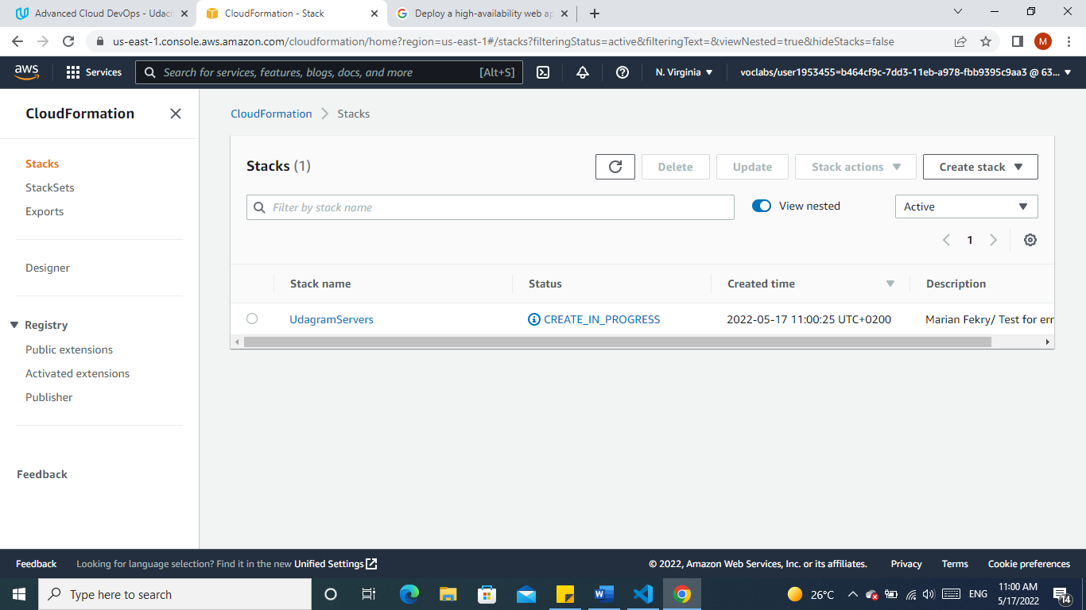
2. Upload the index.html file on S3 bucket

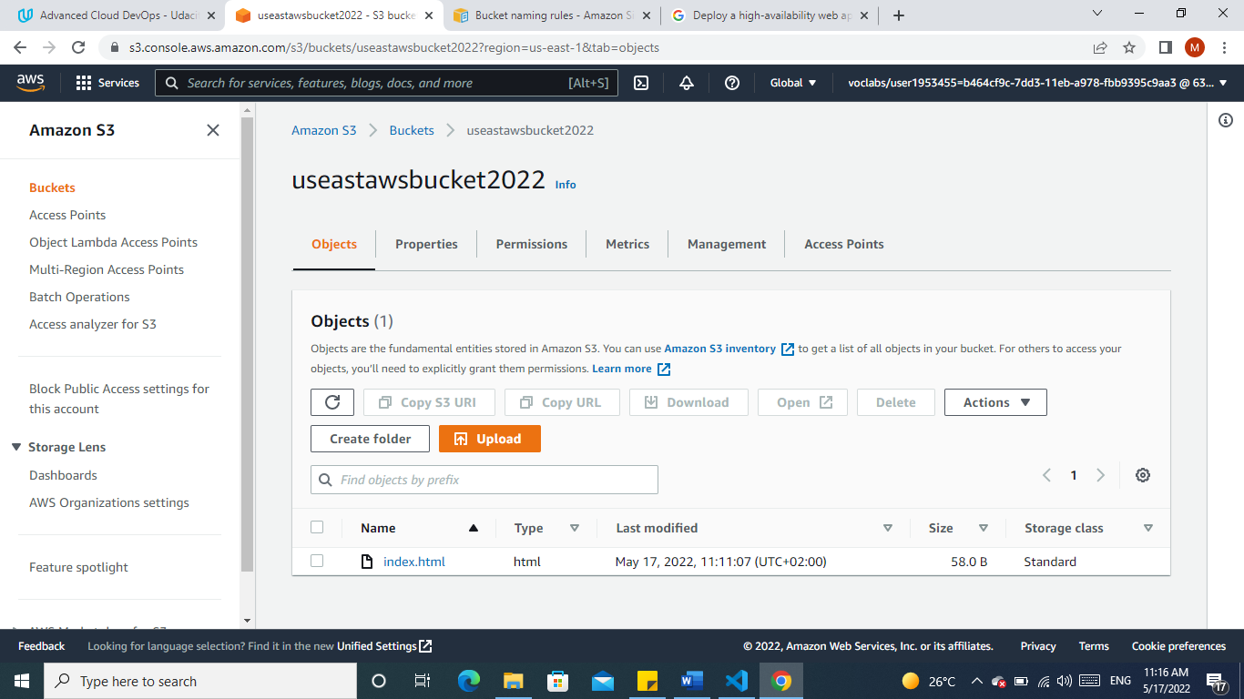

1. 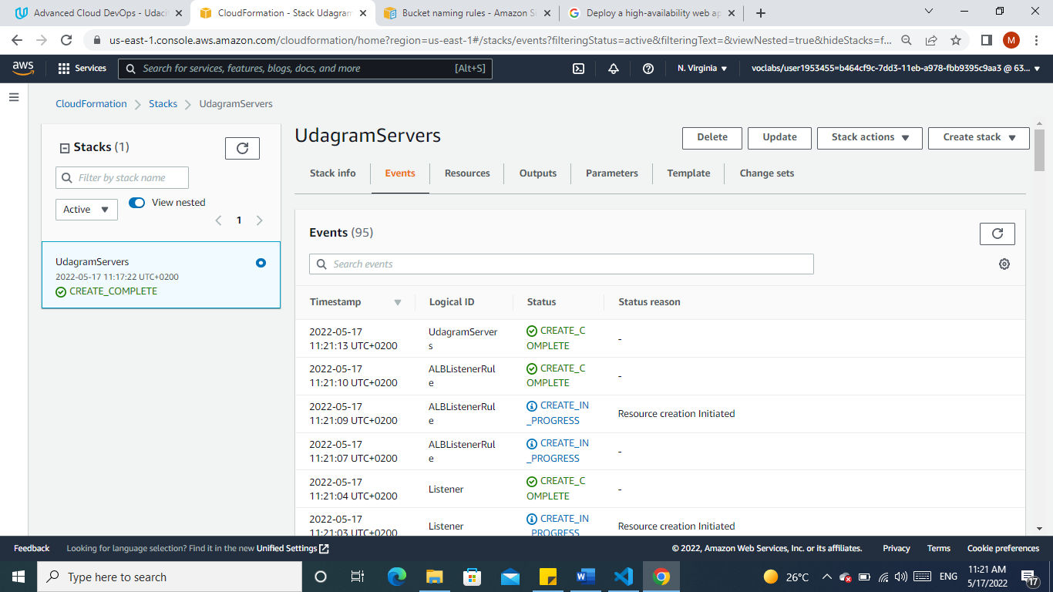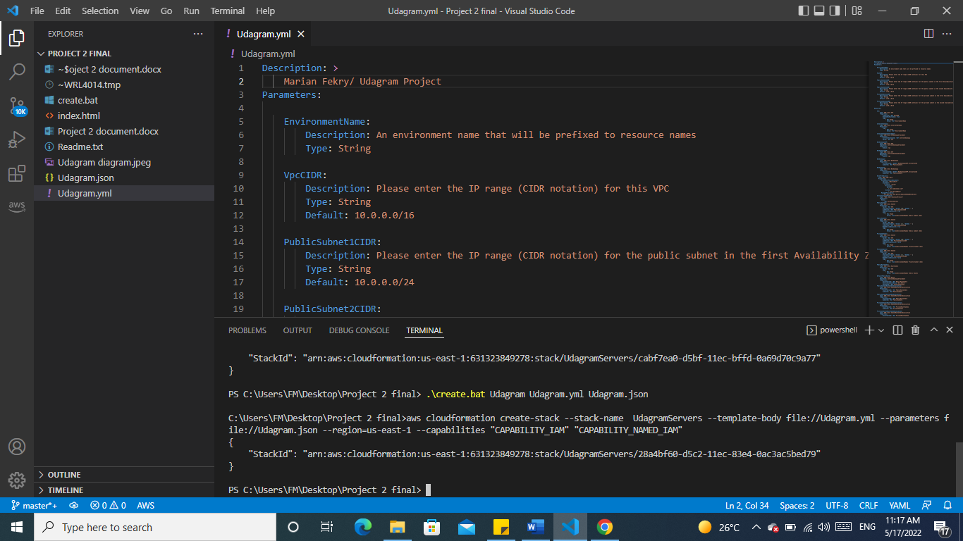Create Cloudformation
2. The output:

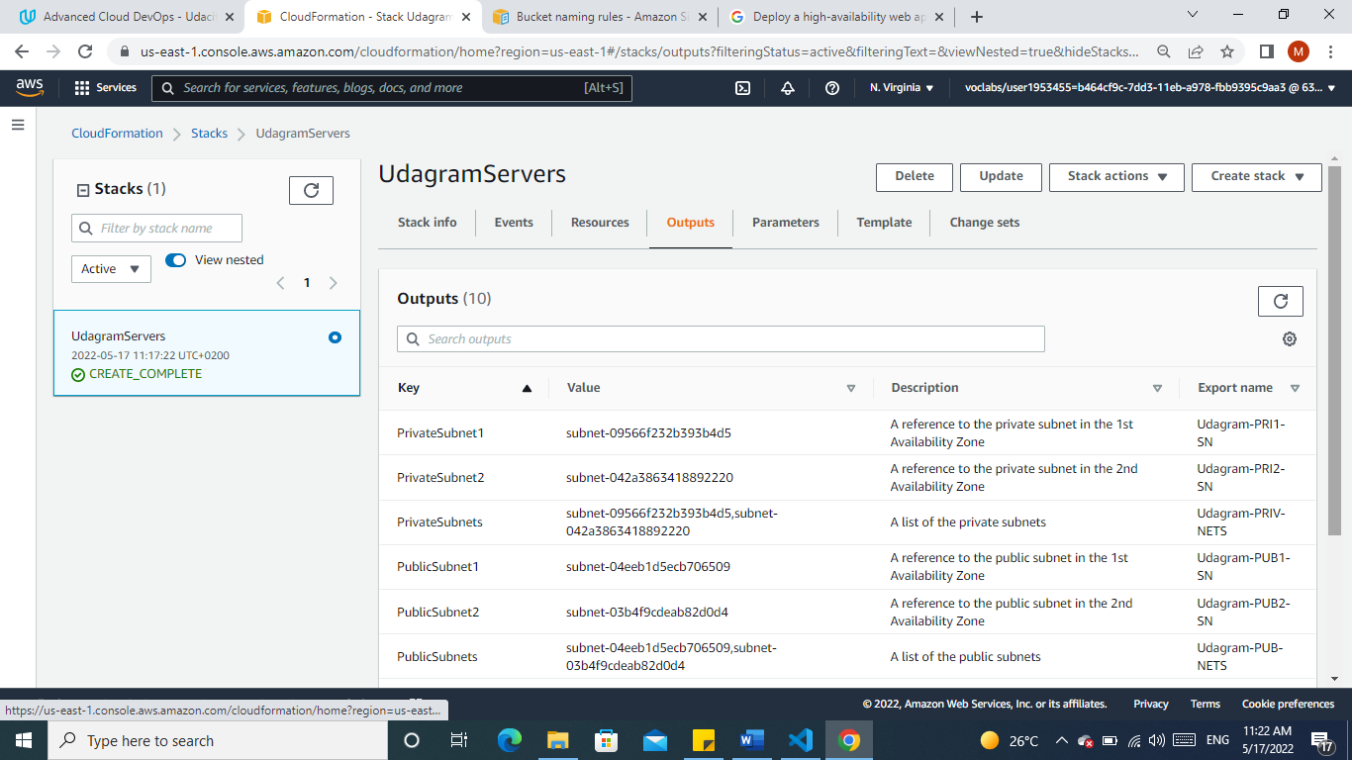

5. Creating the Autoscaling Loadbalancer

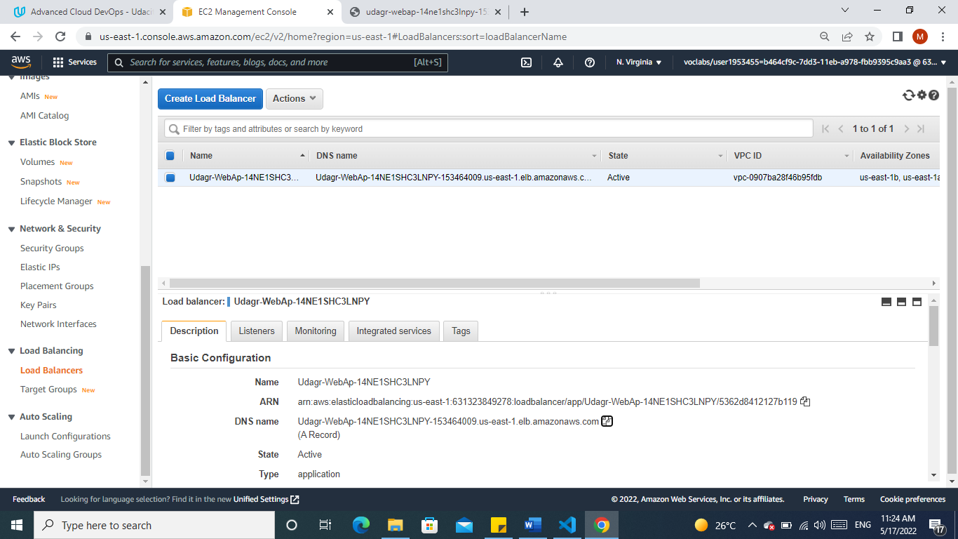

1. 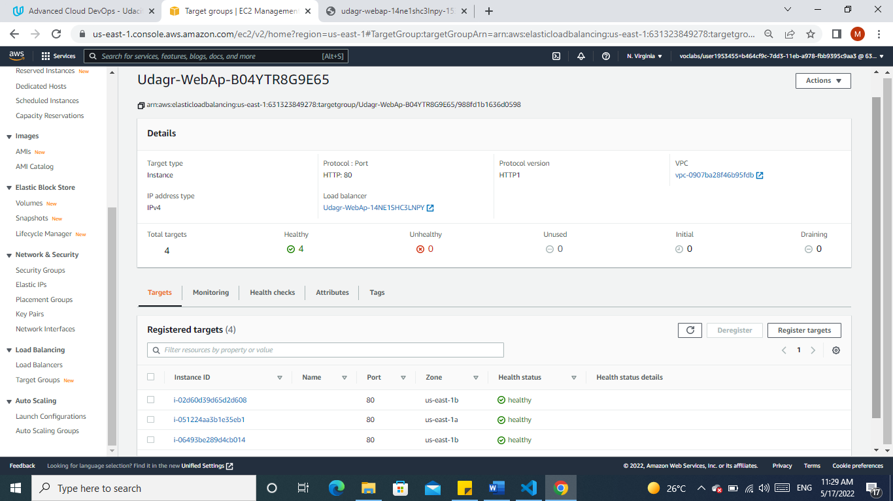Targets up and Running
2. Open the URL

